**Report View**

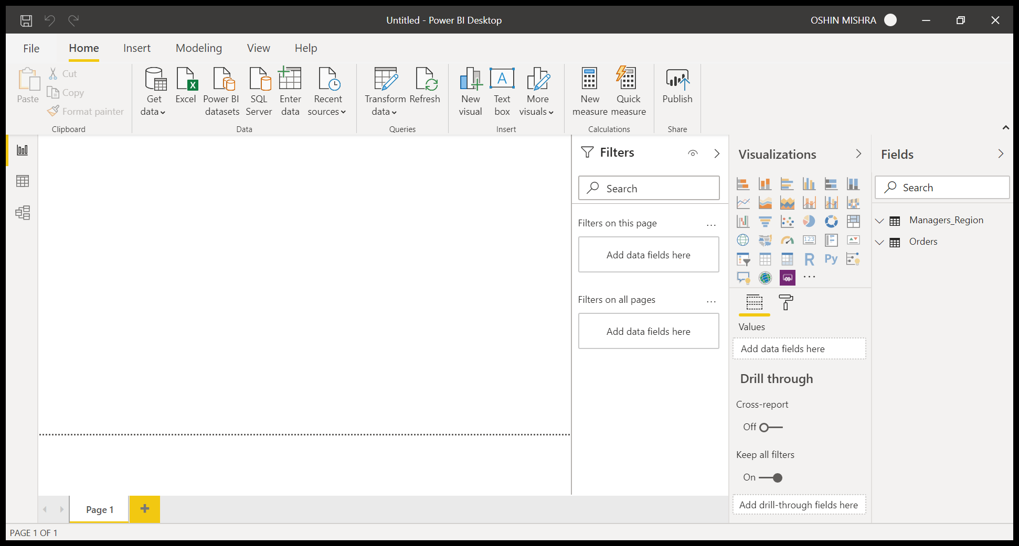

**Data View**

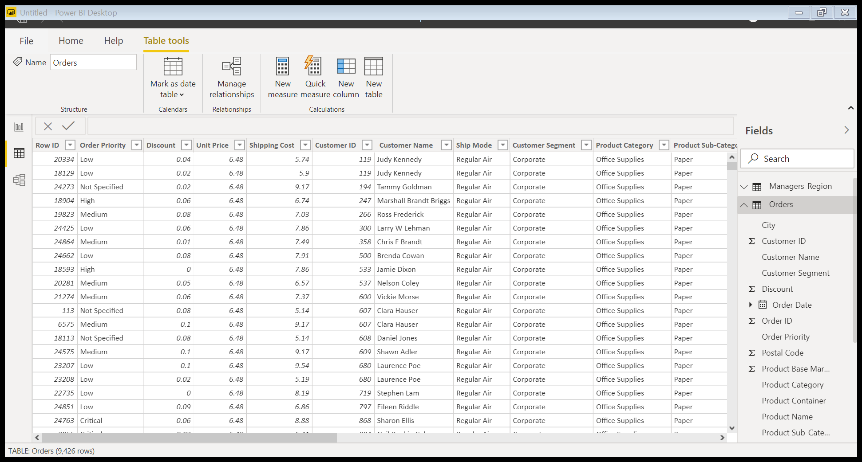

**Model View**

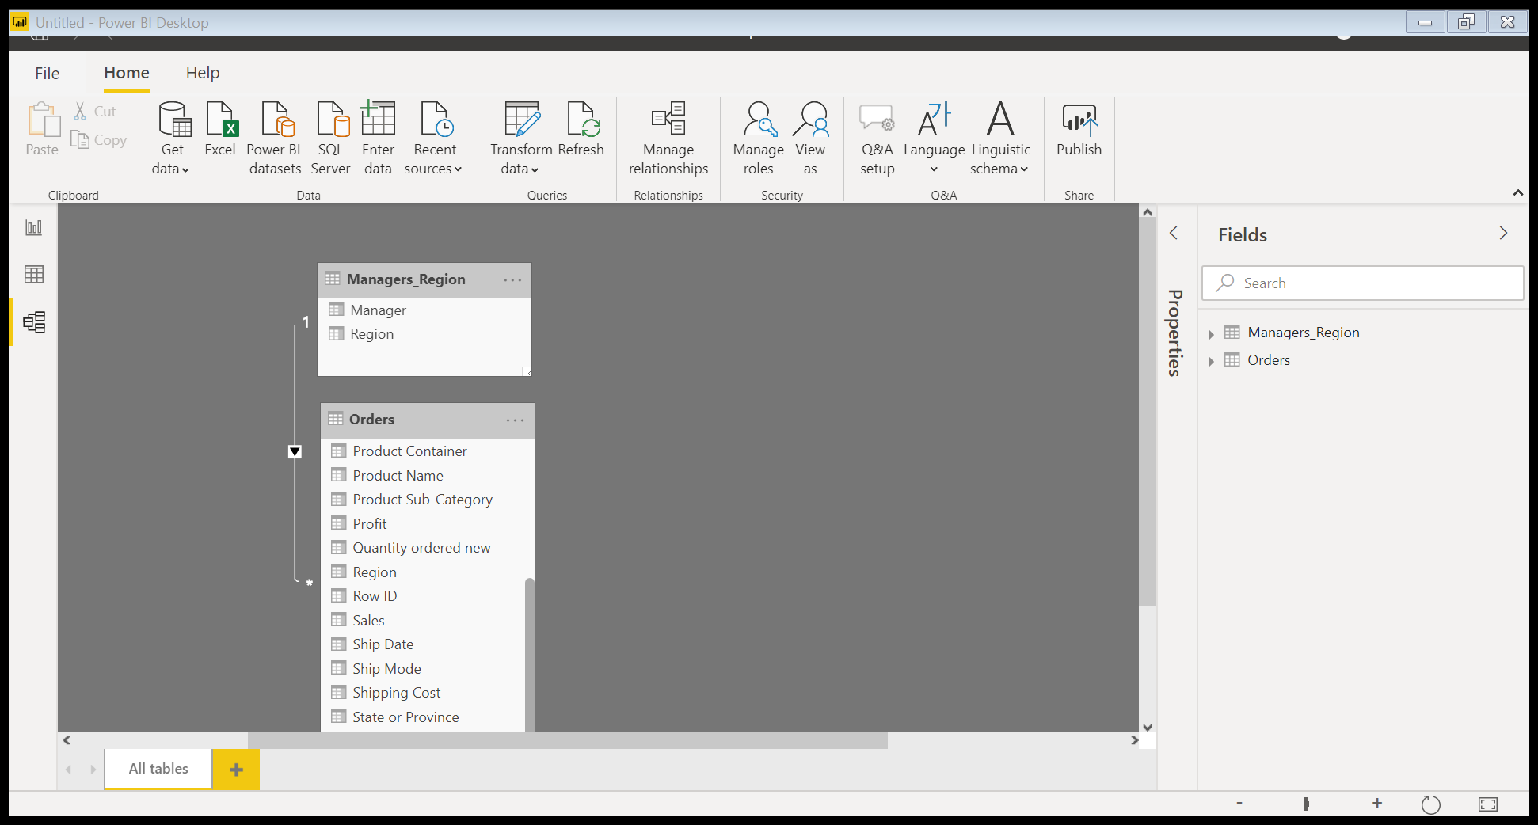

**Power Query Editor**

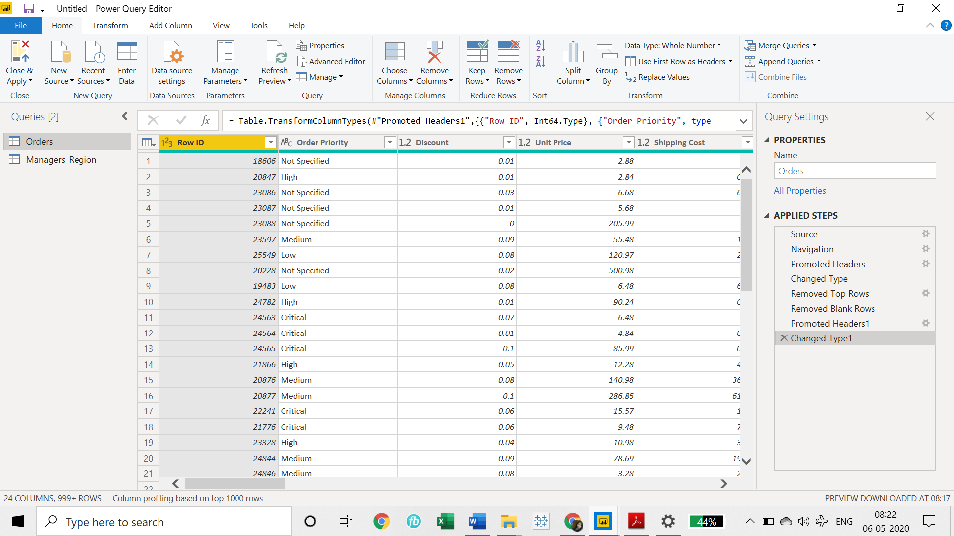

**Advance Editor**

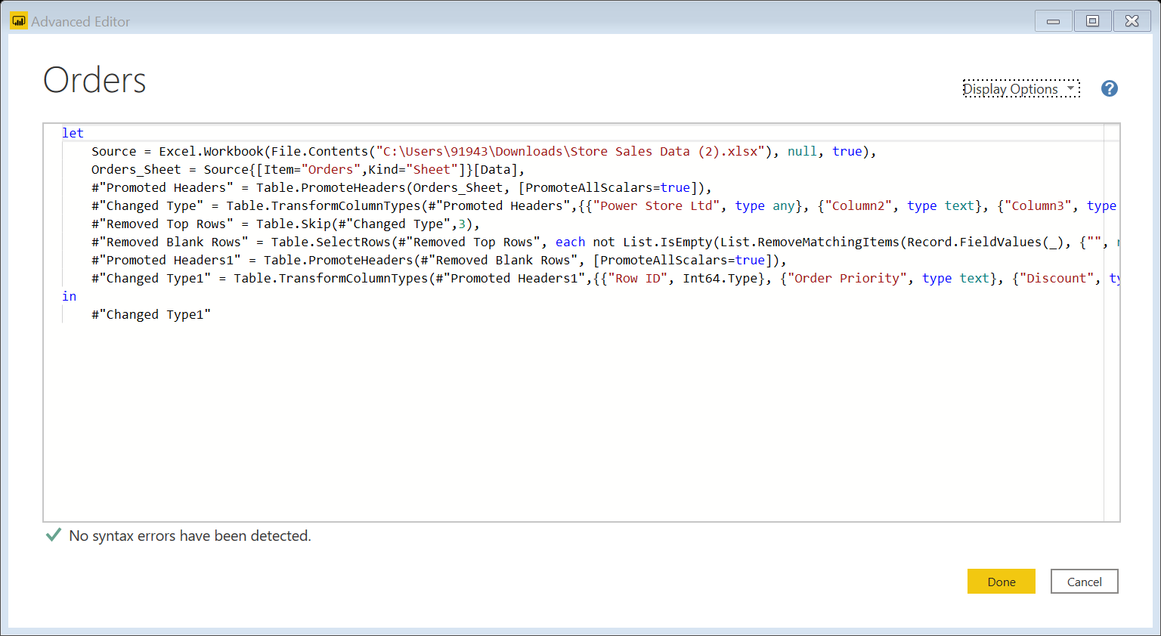

|  |  |
| --- | --- |
| **Product** | **Price(Monthly)** |
| Power BI Desktop | Free |
| Power BI Pro | ₹660.00 per user |
| Power BI Premium | ₹330,190  Monthly price per dedicated cloud compute and storage resource with annual subscription |